Author: Stav Salpeter (15).
Student at Birralee International School, Trondheim, Norway
Project presented at Birralee Science Fair, 19.03.14

My teacher set us off on this project with the question “What do you care about?”
Admittedly, animal rights were not the first thing that came to my mind; but when it did, it remained there. What was truly the difference in the condition of chickens in different sorts of cages? We pay more for Free-range eggs, and even more for Ecological ones, but what is actually the difference?
I decided to check the nutritional value of eggs because it seemed to be the most straightforward approach.
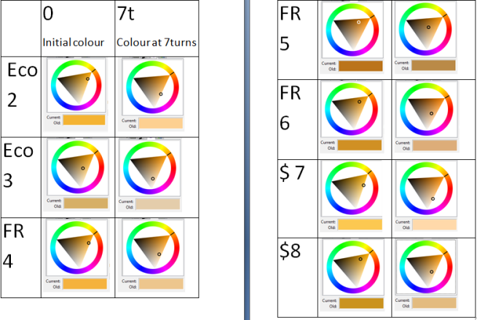
I began by collecting background information to find out which nutritional aspects were most admired in eggs (which I could test with the tools available to me). Then I set out my plan, writing how I was going to go about getting my results. This stage included trying out different methods of shaking test tubes to find the fairest I could get. Once all the ideas were ready, I began the experimenting, checking for fat and protein using the ethanol and biuret tests, but I believe it was the deciphering of the results that was hardest.
I used an artist’s programme suggested to me by my teacher to examine the colour difference between the egg samples before and after the tests. The analysing was hard because there seemed to be too many factors which could have caused the colour change besides the chemical tests. (See B3 for further details)
Even though I did not get my answer in the end, I believe that I have learned a lot from the scientific process. At every stage, I noted my observances and findings, and this is my report.

Note: Actions to keep test fair, reliable, and accurate are marked with *

Planning Stage
Aim: will test Ecological, Free-range and Economical eggs for amounts of each ’nutritional entity’ in respective experiment, and compare results.
I have 6 of each type of egg.
I will start with numbering and recording the weights of all the eggs.* I will take a picture of the jars to later examine the colour change with the artists’ program GIMP (http://www.gimp.org/) .
I will use 3 eggs of each type and mix each in its own jar with its own (or a re-washed mixing item). I will do the fat test first, as it only requires a few drops of egg. Once I start on it I will cover up the egg mixes.* I will then proceed to do the Protein check.

I will either re-wash or use several test-tubes, droppers, and mixers. *
Ideally I would divide the eggs into four parts to have two versions of each test on each egg for accuracy*, ask Mrs. Stacey for possibility of this time-wise.
In short:
- Name and label eggs.*
- Weigh and note weight of eggs.
- Break each egg right before its use. Note order of breaking (so the eggs will have had as equal an air-exposion as possible before the protein test.)* Check and note yolk colour.
- Fat test.
- Protein test.

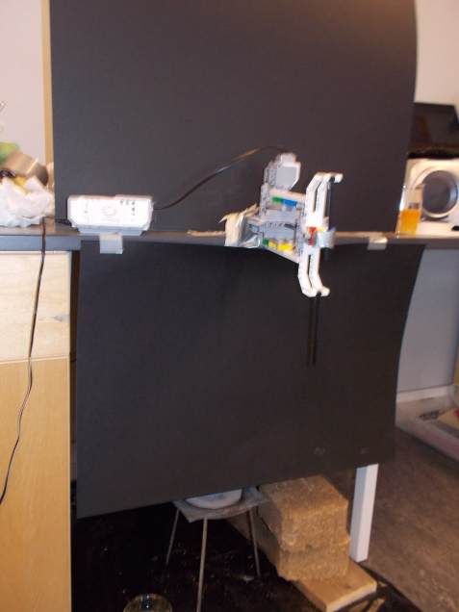
Experiment Plan: Checking for Fat
Background Research: (almost or) all the eggs’ fat is found in the yolk. However, to keep the test fair, (as I do not know what influences the distribution of fat; and if the egg type has any effect), I will use a yolk/white mix.*
Fat is used for storage of energy and somewhat for insulation in humans (buoyancy in some other animals as well).
Equipment List: test tubes, ethanol, Lego Mindstorm mixing machine built by my teacher for shaking (see picture, or http://www.lego.com/nb-no/mindstorms/?domainredir=mindstorms.lego.com) , camera+lighting+black background screen to check colour, stopwatch, pipettes

Proposed Method:
- Mix four drops of egg mix and 1 ml. ethanol
- Use Mindstorm to mix test tube equally* [note no. of mixes needed]
- Film the mixing to compare later, or use Mindstorm to check colour after chosen numbers of mixes/seconds, while controlling lighting to be identical, and using black background.* Solution turns cloudy white in presence of fat.
Risk Assessment: ethanol is flammable, be careful.
A prediction: More fat in Economical eggs, less in the Free-range and least in the Ecological. The chickens laying the Economicals have less opportunity to move and use fat.

Experiment Plan: Checking for Protein
Background Research: It is known eggs contain high protein levels. The protein is distributed almost evenly between the yolk and the egg white, so I will have to test both for it.
Protein is made of amino acids, and is used in growth and repair of cells and in making new ones.
Equipment List: several test-tubes, sodium hydroxide (NaOH), mixing Mindstorm machine, copper sulphate (CuSO4), pipettes, camera+lighting to check colour

Proposed Method:
1. Mix equal amounts of NaOH and egg mix in test tube. Mix equally, for 4 ‘Mindstorm Mixing Machine’ turns. *
2. Add 2 drops of CuSO4 solution
3. Check how purple solution gets with Mindstorm or take photo with camera to check later, while controlling lighting to be identical.*

How to keep test fair, reliable, and accurate: also marked with *
Risk Assessment: Sodium Hydroxide may be a risk for skin, wear gloves?
wear safety goggles.
A prediction: Most protein in Ecological eggs because of more varied natural diet. Maybe a slight difference between Free-range and Economical eggs, with free range higher in protein.

Later NOTES about stage:
Sadly, 1 egg had more time with NaOH, no time to redo. No time to do each egg more than once.
In Fat test taped camera to place to ensure equal lighting * Tried not to depend on outside light, * but not all shutters would close. Poster taping on windows * was not enough. In Fat test completely depended on window light, in Protein test had indoor light as well, but it was too bright.

Analysing Stage

B1) Results-deciphering plan:
- Organise & number videos
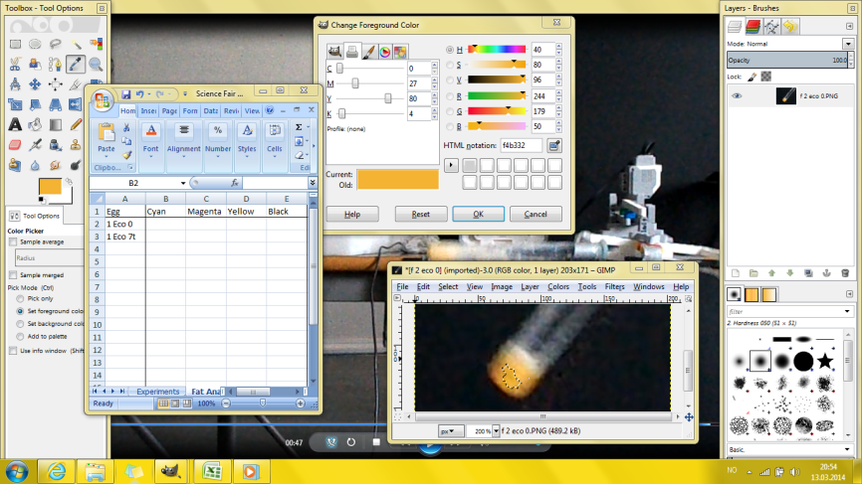

For Fat test:
- Play each video, taking screenshots of test tubes before doing 1 turn (0) and at/after 7 turns (7t). Try to make both these shots at around the same point in the test tube’s turn, so that the lighting will be identical *
- Open each picture with GIMP (Gnu Image Manipulation Programme). Use the ‘select by colour tool’, trying to select a representative swathe of colour; one that covers a vast area of the liquid in the test tube, and that is not too effected by deep shadow/bright light, preferably near the centre of the test tube. *
- Now analyse the colour picked using the program. Since the eggs should turn cloudy white at contact with alcohol, I should be looking at levels of Black(K), Saturation [S], and Value [V].
- Note my results into a spreadsheet, calculating changes in these numbers as percentages (result/start no. >>> 7t/0). Eventually calculate the average percentage change for each type of egg.

For Protein test:
- Play each video, taking screenshots of test tubes before doing 1 turn (0) and at/after 10 turns (10t). Try to make both these shots at around the same point in the test tube’s turn, so that the lighting will be identical *
- Repeat stage 2 of Protein results analysis.
- Now analyse the colour picked using the program. Since the eggs should change colour, I should be looking at levels of Hue(H), Green, Yellow, Red, Magenta, Blue and Cyan.
- Note my results into a spreadsheet, calculating changes in these numbers as percentages (result/start no. >>> 10t/0). Eventually calculate the average percentage change for each type of egg.

Background research:
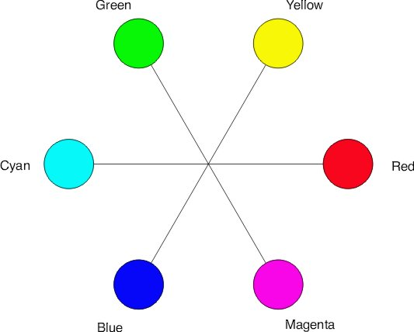
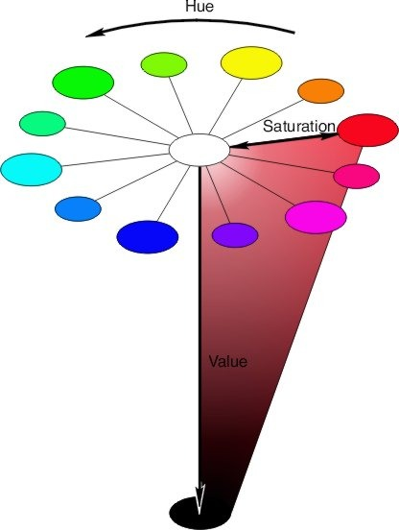
From Color Principles - Hue, Saturation, and Value by North Carolina State University: http://www.ncsu.edu/scivis/lessons/colormodels/color_models2.html#hue. (pictures from source too)
” How light or dark a color is is referred to either as a colors lightness or value”
” Saturation refers to the dominance of hue in the color.”
” Hue is described with the words we normally think of as describing color: red, purple, blue, etc”
From playing around with GIMP: higher value>more light
lower saturation>closer to white
Hue of 60>yellow, the bigger number the greener
Later NOTES about stage: I also took screen shots of the CIE models of the Fat eggs’ colour so these could be compared visually.
I did not use videos of eggs with too few turns or different lighting. *

B2) Results:

Key:
$>economical FR>Free Range eco>ecological
f/Fat>fat test p/Pro>protein test avg.>mean
0>before 1 turn on Mindstorm mixing machine
7t/10t> at/after 7turns/10turns on Mindstorm mixing machine
Fat Test Results:
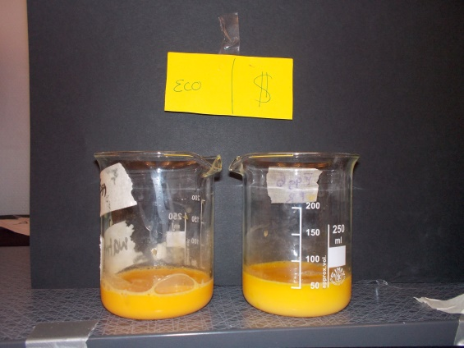
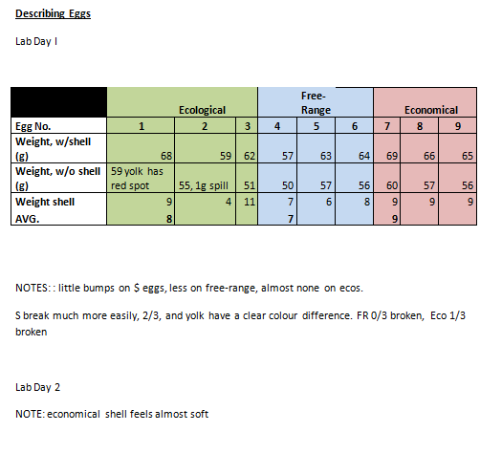
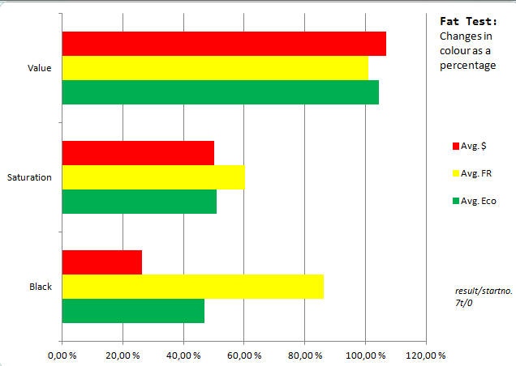
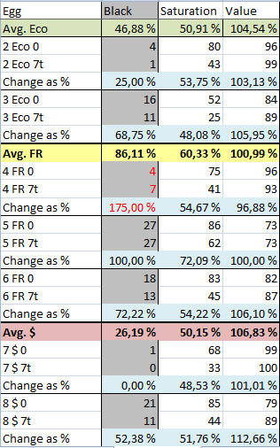
Fat Test Results:
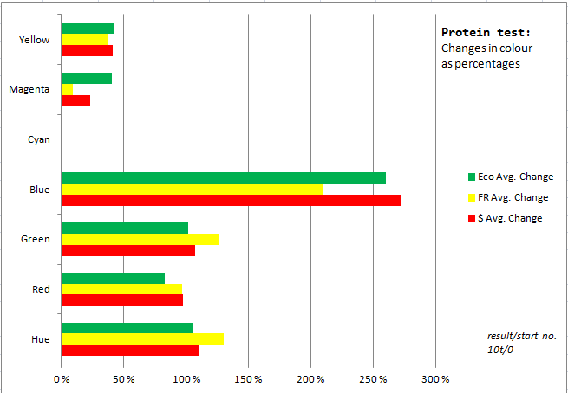
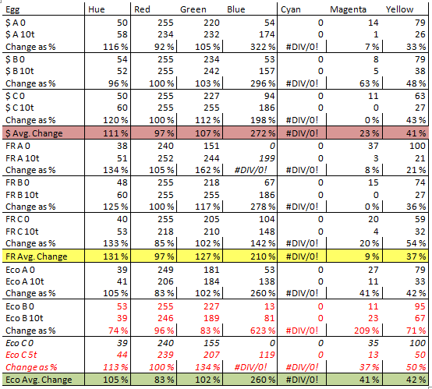
Protein Test Results:

B3) Analysing Results:
Analysis, Conclusion, and Evaluation:
Shell Weight: There is a slight difference in shell weight: the economical shells being the heaviest and the free-range shells the lightest. This would make sense, as the eggs were all categorised differently by the sellers, the FR were ‘M’, the Ecos were ‘M/L’, and the $ were ‘store’. Since they were all ‘chosen’ for their size, it is unfitting to make any conclusions about calcium levels/probability of bacteria entering egg.
Fat Levels:
I will disregard the ‘Black’ results of egg 4, whose irregular value is probably be the result of the lighting (different lighting in different place of test tube in mixing machine’s circle; different lighting due to more/less clouds; different lighting due to figure blocking lighting).
There is a clear correlation in all three measurements. The highest whitening is always at the economical, then the ecological, then the free range. This means economical eggs contain the most fat, followed (very) closely by the ecological eggs, while the free range eggs contain the least fat.
This is almost the same as my hypothesis [“More fat in Economical eggs, less in the Free-range and least in the Ecological. The chickens laying the Economicals have less opportunity to move and use fat.”] and makes sense for the same reason.
There may be less fat in the Free Range eggs than in the Ecological as it is winter and the latter are probably not let out¨, thus having less space to roam about. Alternatively (or in addition) they may eat better/more fat-rich food than the Free Range hens.
[Whitening in Saturation and Black is seen as lower results, and in Value as higher. See Background info. about colours.]
¨ ” I tillegg har de tilgang til et uteområde med vegetasjon, når det ikke er for kaldt.”” http://dyrevennlig.org/dyr/hoener-og-kyllinger/frittgaaende-hoener-oekologiske-hoener-bedre-dyrevelferd/
Protein Levels:
I will disregard all results of egg eco C as it only took 5 turns with the Copper Sulphate (due to test tube support failure). Even though I double checked them, I will remove the results of egg eco B as they are so out-of-proportion from the rest, probably due to lighting.
There was that dilemma: which colours should I look at? Red was quickly out of the picture; it was indeed part of the sought after purple, but it was also part of the original orange of the yolk which was meant to disappear. Magenta followed: even though it was theoretically the sought after colour, its receding levels proved it was more prominent as part of the receding orange of the yolk. Cyan of course was not present at all, and Hue could not be trusted, as its figures simply name the location of the colour on the colour wheel, which is obviously not followed number by number by the chemical reaction.
Then I had two groups: ‘how much of the egg changed colour’, represented by how much yellow had receded, and ‘to what extent the egg changed colour’ represented by the increasing of blue and green. But these last two had distinct results! To see which would affect the egg into the sought after purple, I exaggerated their levels, separately, on a random egg-in-test-tube (before CuSO4) on GIMP. These were my results:
All Green added:>yellow
All Blue added:>purplish!
Of course! Blue was the colour I was after! And the results of yellow agreed with those of the blue! According to this, then, there is most protein in Economical eggs, then Ecological, then Free Range in the ratio 1.05 : 1 : 0.81
This proves my theory wrong! [Most protein in Ecological eggs because of more varied natural diet. Maybe a slight difference between Free-range and Economical eggs, with free range higher in protein.]The truth can be attributed to me underestimating the ‘Economical’ chickens’ diet, or, more likely, to the same reason as the fat test results: the Economical chickens living indoors for the winter.
Evaluation:
I do not believe this test was trustworthy.
It all comes down to the resources.
First of all the eggs. They were not of the same size, not laid in the same date ($ bestbefore 17.03, eco bestbefore 10.03, FR bestbefore 07.03, although eventually I tried to use them in order of their expiry.)( Also, even though I did try to let them have the same amount of time in the refrigerator and out, the time before they reached the supermarket was out of my control), not completely representative (i.e. they came from only three egg farms), and ultimately, were not enough. At certain stages (such as the Economical eggs of the Protein test) I only had one egg to represent a whole egg type! (mostly due to lighting problems) This cannot be expected to show any definite conclusions.
Then there was of course the lighting that was not equal enough, varying the appearances of the colours in the test tubes. And the colours themselves I was unsure how to analyse; isn’t the blue I’d relied so much on the opposite of yellow, and thus naturally to be expected to correlate with it? Consequently my results for the Protein test would only show ‘how much of the colour changed’ (and not ‘how much the colour changed’).
But the resource that I was lacking most was time (much of which was due to my wasting/bad planning of it). With more time, I could’ve sourced down more representative eggs. I could have made a system to adjust fairer lighting. I could’ve figured out how to analyse the colour change. And then, I could’ve made more tests: not only from more eggs, but two tests from each egg, and two colour analyses for each test. I could’ve made more types of tests (i.e. not only fat & protein).
That being said, I believe that I did my best with the ‘resources’ I had. I did try to make the test as fair as I could, but due to the reasons stated above, I cannot consider my experiment to have given a reliable answer to my initial question of: “What is the difference in the nutritional value of Economical, Free Range, and Ecological eggs?”.

